Frontline Staff Enabler: Complete Guide to URN Certification, Insurance Exam & Training Process

1. Introduction
This guide equips frontline staff with in-depth knowledge to assist prospective insurance agents or SP (Specified Person) in completing the mandatory IRDAI certification process. From registration to certification and onboarding, this guide ensures a smooth journey for candidates.

2. Understanding the Key Terms
Term | Description
URN | Unique Registration Number assigned by IRDAI to candidates registering for the insurance agent exam.
IRDAI | Insurance Regulatory and Development Authority of India – the regulatory body for the insurance sector in India.
NSEIT | A designated exam conducting body authorized by IRDAI.
SP | Specified Person – a certified individual who can sell pre-approved insurance products.

3. Process

The SP certificate is required to be obtained prior to engaging in distribution of insurance products. This certificate can be obtained after successfully completing the online self-paced training and passing IRDA online exam. SP certificate is obtained after successfully passing the exam (minimum 35% is required for passing).

3.1 Expiry & Renewals:
The SP certificate is valid for a period of 3 years. This certificate can be renewed for a period of 3 years by attending a renewal training course by IRDA.
It is the responsibility of the employee to ensure that their Certification is renewed and updated prior to expiry.

4. Step-by-Step Process for obtaining SP Insurance certificate

4.1 Document Submission
Purpose: To register a candidate with IRDAI and obtain a Unique Reference Number (URN).
Process: The candidate needs to send mail with all the details to the Insurance product team. The said team will create URN (Unique Registration Number) and register the candidate for the 75hrs mandatory training.
4.1.1: To create URN and enroll for training, the candidate needs to send mail to Insurance product team with personal details mentioned below alongwith own photograph, photograph of signature and photocopy of Basic qualification certificate (All should have file size of less than 50kb). – Refer to the attached form (Excel file)
TAT: 2-3 working days depending on document verification.

4.2 Training payment and enrollment

Purpose: To educate candidates in compliance with required mandates.
Training Requirements:
Certification Type | Minimum Training Duration | Mode
Composite | 75 hours | Online

Registration on Portal – Once the candidate registers and makes the payment for training, the candidate will receive a confirmation mail to complete the 75 hours training before the due date (within 3 months)
Refer to the attachments to register and make payment for training – Flowchart for SP training
Training process: Refer to attachment – Flowchart for using III portal
After the 75 hours mandatory training is completed, the candidate must inform the Insurance product team, and they will register the candidate for examination.

4.3 Exam batch creation
Purpose: To make the candidate eligible for selling Insurance in compliance with IRDAI mandates.
Examination Process:
Candidates need to inform Insurance product team about the completion of training, and they will register the candidate for examination. The examination process is sent on e-mail by the Insurance product team as shown below.
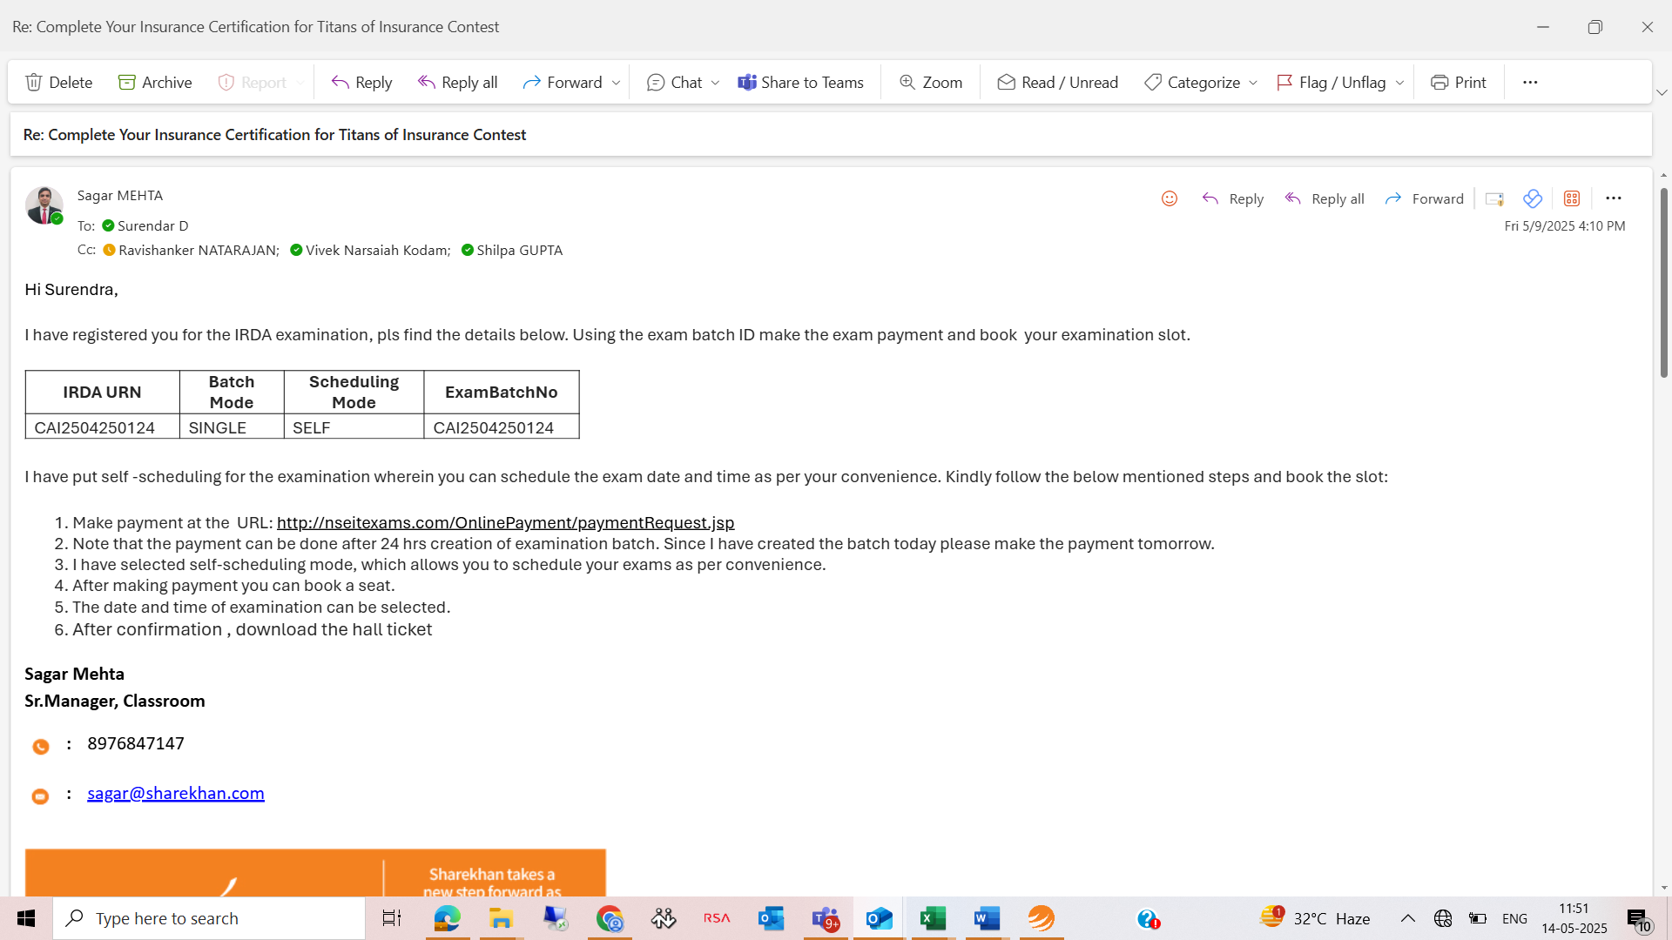
4.4 Exam Registration
Purpose: To make the candidate eligible for selling Insurance in compliance with IRDAI mandates.
Process: To enroll for exam, refer to the attachment – Steps for Examination
SP certificate is obtained successfully after passing the exam (minimum 35% is required for passing).
4.5 Exam Completion
Once the candidate clears the exam, the following documents are required for mapping SP certificate in MASK code. The following documents needs to be shared with insuranceoperations@sharekhan.com
- PAN soft copy
- Aadhar soft copy
- Graduation/post-graduation soft copy (whichever is applicable)
- Training completion certificate
- Examination passing certificate
- Mobile number
- Official email id
- Employee ID
5. Exception cases:
The candidate needs to start and complete the training in 3 months from URN creation date. If not completed, then payment needs to be made again.
If the candidate fails to clear the exam, the candidate needs to reappear.
The validity of the Insurance certificate is 3 years, if the validity is getting expired than the candidate needs to inform Insurance product team and Operations team.
If the candidate is a new joinee, the employee needs submit the NOC of previous organization and SP certificate to insuranceoperations@sharekhan.com

