SALES PROCESS MANUAL
for
Corporate Fixed Deposits
July 2022
Product Management Marketing Team

Index
Purpose 3
Scope 3
Channels 3
Customer Segment 3
Sales Process 4
Business credit/Client Mapping 4
Documentation 4
Transaction Reporting (Business Credit) 4
Training and Certification 5
Sales Quality/Mis-selling 5
Post Sales- client servicing 5
Do’s and Don’ts 5

Purpose
The purpose of this manual is to serve as a guiding document for frontline and any other channel involved with the activity of sales of corporate fixed deposits

Scope
This manual covers the sales process of corporate fixed deposits only. Also, this manual does not include the process followed by our business partners/ franchisees.

Channels
Below are the various channels for supporting sale of corporate fixed deposits at Sharekhan.
Channel | Role | Mode
Individual Contributor Roles | All RMs from segments:  - Sharekhan One  - Super Investor  - Super Trader  - Retail  - Sales and Onboarding  are eligible for cross selling corporate deposits. | Offline only (as of now) until the online system is integrated on our website

Customer Segment
Corporate Fixed Deposits can be bought by existing Sharekhan clients. Non Sharekhan customers could be those who do not have an account (DEMAT or MF) with Sharekhan or could be in the process of opening an account with us but want to start investing right away. After having invested in corporate FDs through Sharekhan, these customers will become Sharekhan clients. However, we cannot have clients holding only corporate deposit products with us without being a Sharekhan client.

Sales Process
The CDs can be sold through:
- Physical Branch network
  - Through SK Staff
  - Branch Walk-ins
Currently, customers can invest in corporate fixed deposits through the offline route only, below is the generic process that needs to be followed by the frontline to sell corporate deposits.
Physical Channel
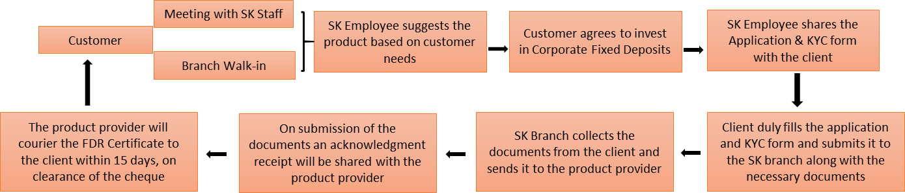

Business credit/Client Mapping
- Product team will be responsible for maintaining the data for orders punched under our distribution code.
- Data will be shared on a monthly basis with all employees
- MIS will be created based on DPMS mapping for investments in corporate fixed deposits
- Business credit will be given to relationship managers as per the client’s mapping in the DPMS systems.

Documentation
All documents are retained in physical form with the product provider, and will be shared with Sharekhan on demand. All relationship managers engaging with clients on corporate fixed deposits must follow the documentation process as prescribed by the product provider

Transaction Reporting (Business Credit)
Business credit will be given to relationship managers as per the client’s mapping in the DPMS systems. Incentive will be as per incentive policy of respective segment. It will be announced and managed by the respective segment.
Please note that if a corporate deposit is sourced by an employee of the sales and onboarding team then the sales credit for the same will be equally shared with the employee to whom the client is mapped to (from the segment) within 3 months of sourcing the deal. The credit sharing will be as follows:
For business sourced within 3 months of account opening for accounts opened by Sales & On-boarding team:
Segment RM | 100% | If no Sales or On-boarding team member is involved
Segment RM | 50% | If Sales team member is involved
Sales Executive (if on-boarding team member is not involved) | 50% | If account is not mapped to On-boarding branch
Sales Executive (if on-boarding team member is involved) | 25% | If account is mapped to On-boarding branch
On-boarding Executive | 25% | If account is mapped to On-boarding branch

Training and Certification
Currently, there is no certification requirement for sourcing corporate deposits. All frontline staff responsible for targets can distribute this product. They are required to attend the trainings organized by the product team from time to time.

Sales Quality/Mis-selling
Mis-selling means selling a product by giving a wrong picture of a product, it may include, giving wrong information, giving unrealistic information, not giving full information about the product. It is direct indicator of the Sales quality. The Sales quality would be tracked by the mis-selling complaints from clients. In case mis selling is established the employee will face stringent action from the management included but not limited to clawback of incentive paid.

Post Sales- client servicing
The Relationship Manager sourcing the business is the first point of contact for the customer and will be responsible for helping the customer with the request. Additionally, branch staff shall be available for any servicing needs of the customers. Branch staff will support servicing requirements of customers with the support of the product provider.

Do’s and Don’ts
- Be diligent in attesting / certifying investor documents and performing In-Person -Verification (IPV) of investor's for the KYC process in accordance with the guidelines prescribed by SEBI/ KYC Registration Agency (KRA) from time to time.
- Consider investor's interest as paramount and take necessary steps to ensure that the investor's interest is protected in all circumstances.
- Be fully conversant with the key provisions of the Disclosure Document and the contract being entered between the customer and the FD Issuer.
- Provide full and latest information of the product in the form of interest rates as well as availability of early withdrawal options including risk factors and highlight the assumptions if any.
- Disclose to the investors all material information including all the commissions received for the purpose of soliciting such investments.
- Keep yourselves abreast with the developments relating to the Industry as also to changes in the disclosure documents and other material aspects and deal with the investors appropriately having regard to the up to date information.
- Maintain confidentiality of all investor details, deals and transactions.
- Always keep investor's interest and suitability to their financial needs as paramount and that extra commission or incentive should never form the basis for recommending a product to the investor.
- Do not offer any rebate or commission back to investors and abstain from attracting investors through temptation of rebate/gifts etc.
- Do not undertake commission driven malpractices such as recommending inappropriate strategy solely because of higher commissions.
- Observe high standards of ethics, integrity and fairness in all its dealings with all parties - investors, product provider. Render at all times high standards of service, exercise due diligence, and ensure proper care.

