SALES PROCESS MANUAL
for
Mutual Funds
December 2022
Asset Gathering Product Team

Index
Purpose 3
Scope 3
Channels 3
Transaction Mode Types 4
Account Opening Process 4
Transaction Platforms 5
Customer Engagement Approach 6
Transaction Process 9
Documentation 9
Training and Accreditation 10
Sales Quality 10

Purpose
The purpose of this manual is to serve as a guiding document for sales staff and any other channel involved with the activity of sales of mutual funds.

Scope
This manual covers the sales process of mutual funds. Any investment products managed by other departments/teams within Sharekhan are not part of the scope of this manual. Also, this manual does not include the process followed by our business partners.

Channels
Below are the various channels for supporting sale and servicing activities at Sharekhan. All SK staff responsible for engaging in discussion on mutual funds are NISM certified (VA module) and have their EUIN mapped under our ARN code.
Channel | Role | Mode
Sales | This channel is primarily responsible for broking customer acquisition | Face-to-face
Relationship Manager (All segments) | These RMs are mapped to customers for handling their investment/broking relationship | Face-to-face and Phone/ Non-Face-to-Face communication
Dial-N-Trade RM | Channel for supporting customer calls for transacting in DEMAT or MF Account | Phone (Inbound)
CRE | Telephonic RMs who handle inbound and outbound calls and emails from and to customers. | Phone (Inbound), Non-Face-to-Face communication & Email (myaccount@sharekhan.com)
Sales leadership  Territory Managers  Regional Heads  Regional Sales Managers  Team leaders  Branch Head  City Head/Group Head  Group Head  Cluster Head | Sales leadership is also responsible for MF sales | Face-to-face and Phone/ Non-Face-to-Face communication

Transaction Mode Types
Customers of Sharekhan can transact through the following modes:
- DEMAT Account holder (DEMAT Mode) – this is used for direct equities, fixed income, mutual funds, etc.
- MF Account holder (NON DEMAT mode) - this platform is specifically for mutual funds only
Both these accounts are linked with the customer’s registered bank account. Using the registered bank account, the customer can transact by directly initiating payments to BSE STAR in the payment modes available. The customer can also provide an auto invest mandate in favour of BSE with a maximum threshold amount for debiting his/ her account for Lumpsum/Systematic Investment Plans (SIP) transactions. The mandate threshold amount starts with Rs 1 Lakh.
A customer can choose to transact in either of the modes.
Non Sharekhan customers (KYC Compliant) can also invest into mutual funds by quoting our ARN on the investment form and submitting it along with cheque/ NEFT/ RTGS at any of our branches. These customers could be those who do not have an account with Sharekhan or could be in the process of opening an account with us but want to start investing right away.

Account Opening Process
An account can be opened in the following 3 ways:
- Through SK Staff (providing relevant documents following a meeting)
- Branch Walk-ins
- Online (DIY)
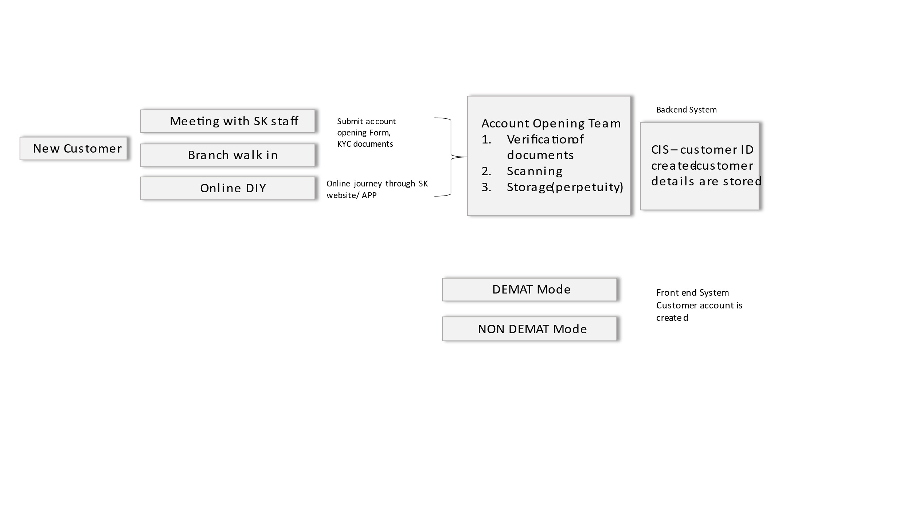

All Sharekhan account holders have a unique customer identity number (Cust ID/S2K ID) in our database which is used as an identifier in the system.

Transaction Platforms
Customer transactions are broadly divided into offline and online transactions. Requests submitted at branch are offline requests and transactions executed by the customer using online account or through requests placed via phone are classified as online transactions.
Offline requests are submitted by customers directly whereas Online requests can be directed by customers and executed by RM/ Customer Service RM. Transactions which are executed on behalf of the customers are only for the purpose of order placement, the money transfer process remains with the customer for purchases and redemptions are required to be authenticated by customers via OTP.
Platform | Transaction Executed by
Branch  - Offline Requests received by branch  - Web Admin  (RM portal for order management) | Customer Service Executive/ Operations/RM (order details)  Money transfer is done by client directly to BSE StarMF
Online:  - Sharekhan Website  - Sharekhan App | Customer
Phone
- Dial-n-Trade (DNT) team | Customer calls on DNT number using his/her log-in and DNT RM executes transaction on behalf of customer
- Phone (other SK staff) | Customer calls on SK staff’s phone and certified staff executes transaction on behalf of customer

Customer Engagement Approach
At Sharekhan, the client engagement process is detailed below:
1. Client Meeting
(Face-to-Face/ Phone)
This stage involves engaging with the client usually in a meeting or interacting over a phone call
2. Financial Need Assessment
During the interaction, the RM gathers information of the client’s investment requirement
3. Execution
To build the proposed portfolio, the client is offered the entire range of mutual funds available including fixed income IPOs available (if any). Here our in-house research list i.e. Top Fund Picks is also shared with the client

Since the investment decision is completely at the discretion of the customer, all transactions are classified as “Execution only”
Transaction is executed as per process detailed in below videos:
SNo | MF Transaction Journey | Link
1 | How to create ACH | https://youtu.be/d9vL58kPcAk
2 | How to create ACH while placing SIP order | https://youtu.be/pgFCZOijTUk
3 | Lumpsum purchase Demat | https://youtu.be/vUef78zb020
4 | Redemption in Demat | https://youtu.be/47mJaa55Uqk
5 | Completing payment for Lumpsum purchase journey through email | https://www.youtube.com/watch?v=V11-gzca8BM
6 | Placing SIP order in Demat Mode | https://www.youtube.com/watch?v=ziq1iySWuEk
7 | Lumpsum purchase- Non Demat mode | https://www.youtube.com/watch?v=BmS_JAj4Dmg
8 | Placing SIP order in Non Demat Mode | https://youtu.be/i6YZ8J0E91E
9 | Redemption – Non Demat | https://youtu.be/4HtxUPqb4EQ

Do’s and Don’ts for the frontline during customer engagement:
Do’s:
- Keep track of the expiry date of your NISM certification & EUIN and ensure that it is valid.
- Stay updated about latest information pertaining to the Mutual Fund Industry including scheme specific information.
- Help customers fully understand the features, benefits, risks and costs of the financial products they buy by doing the following:
  - Provide complete and latest information of schemes to investors in the form of SAI, SID, addenda, performance reports, fact sheets, portfolio disclosures and brochures.
  - Encourage investors to go through SAI/SID/KIM before deciding to make investments.
  - Highlight risk factors of each scheme
  - Disclose all material information to the investor including all the commissions (in the form of trail or any other mode) received for the different competing schemes of various Mutual Funds from amongst which the scheme is being recommended to the investors.
- Ensure that critical operations such as forwarding forms and cheques to AMCs/registrars and dispatch of statement of account and redemption cheques to investors are done within the time frame prescribed in the SID/SAI and SEBI Mutual Fund Regulations.
- Maintain confidentiality of all investor details, deals and transactions.
- Follow the Top picks and other house views provided by the Central team. The house view is what you should be sharing with the customers.
- Ensure to be updated with all sales enablers and generic updates shared vis email id (Investment Solutions) and attend all trainings conducted periodically.
Dont’s:
- Do not misrepresent or exaggerate information
- Do not assure returns in any type of scheme unless the SID is explicit in this regard.
- Collude with investors in faulty business practices such as bouncing of cheques, wrong claiming of dividend/redemption cheques, splitting of applications in the schemes to circumvent regulations for any benefit, etc.
- Do not undertake commission driven malpractices such as:
  - recommending inappropriate products solely because of higher commissions
  - encouraging over transacting and churning of Mutual Fund investments to earn higher commissions.
  - Splitting of applications to earn higher transaction charges / commissions.
- Abstain from making negative statements about any AMC or scheme and ensure that comparisons, if any, are made with similar and comparable products along with complete facts.

Transaction Process
Sharekhan offers mutual funds to its customers in the capacity of a Mutual Fund Distributor (ARN 20669). All transactions are “Execution Only” and any advice is incidental to distribution activity only.
Investor can invest into mutual funds either through DEMAT or NON DEMAT mode through the following platforms:
- Branch – submit a transaction request (AMC application form)
MF applications (along with cheque/NEFT/RTGS) are submitted at branches (either by customer or forms picked up by RM from customers’ office) and processed in the following manner:
- Application form details are logged into CIS.
- Form is then submitted to Head office or RTA whichever is closer for processing
- Non Sharekhan customer details (S2k ID) to be maintained at branch level
- Minor Account Details are not captured in the system

- Online – transact using the log-in details provided at the time of opening the account.
In this case, the customer transacts through his Account at Sharekhan in the available modes (DEMAT/ NON DEMAT). Relevant training documents/ videos for this journey are updated on website under “ACCOUNT” section

- Phone – In this case, the customer calls his/ her RM or Dial-N-Trade team for placing the transaction request. Transaction is placed by the RM/ CRM through Web Admin system. The customer needs to complete the payment/ authentications with in the cut off timings to ensure successful execution of the order.
All transactions are processed as per cut-offs applicable are reconciled as per TATs (2-3 days) by Head Office through reverse feeds from RTA/ Exchange. Transaction confirmation email and SMS is sent by Head office to customers and systems are updated to reflect the transaction and final holdings. Statements are sent to customers monthly by Head Office.

Documentation
All documents are retained at the HO in line with document retention policy.
Physical Forms
Transaction forms – mutual fund transaction forms received at branches are sent either to HO or RTA centers whichever is closer after capturing details in CIS for processing. Photocopies of these forms are retained at branch office by the operation executive at the respective branch for query handling relating to transaction.
Online transaction logs are captured in the system as per the process and regulation.

Training and Accreditation
All customer-facing staff involved in sale of mutual funds must be NISM certified and should a have a valid EUIN under Sharekhan ARN. No sale is allowed by non NISM certified/ EUIN staff.
NISM certification/ EUIN is closely tracked and reported on a regular basis by compliance team.

Sales Quality
Currently sales quality is tracked through sale of funds that are outside the top fund pick list as a proportion to total sales. Cluster level & Organization level reports are sent on periodic basis covering Gross Equalized Sales, Net Equalized Sales, AUM and incremental SIP Flow (90% and above).
Employee level reports are shared by the respective segments as per their KPIs. Going forward more reports will be developed to track and monitor sales behavior.

