SALES PROCESS MANUAL
for
Portfolio Management Services
December 2021
Product Management Marketing Team

Index
Purpose 3
Scope 3
Channels 3
Customer Segment 3
Sales Process 3
Business credit/Client Mapping 4
Customer Engagement Approach 4
Documentation 5
Transaction Reporting (Business Credit) 5
Training and Accreditation 5
Sales Quality/Mis-selling 6
Post Sales- client servicing 6
Do’s and Don’ts (Code of Conduct) 6

Purpose
The purpose of this manual is to serve as a guiding document for frontline and any other channel involved with the activity of sales of portfolio management services (PMS) products.

Scope
This manual covers the sales process of PMS Products only. Any investment products managed by other departments/teams within Sharekhan are not part of the scope of this manual. Also, this manual does not include the process followed by our business partners/ franchisees.

Channels
Below are the various channels for supporting sale of PMS products at Sharekhan.
Channel | Role | Mode
Individual Contributor Roles | All RMs in each segment Sharekhan one, Super Investor, Trader & Retail are eligible to cross selling PMS products unless specified otherwise at PMS portfolio level. PMS can be offered the existing clients and RMs can also acquire new clients through this product | Face-to-face

Customer Segment
PMS products can be bought by both existing Sharekhan clients and non Sharekhan clients. Non Sharekhan customers could be those who do not have an account (DEMAT or MF) with Sharekhan or could be in the process of opening an account with us but want to start investing right away. After having bought PMS products through Sharekhan, these customers will become Sharekhan clients

Sales Process
The PMS product shall be sold through:
- Physical Branch network
  - Through SK Staff
  - Branch Walk-ins
Physical Channel
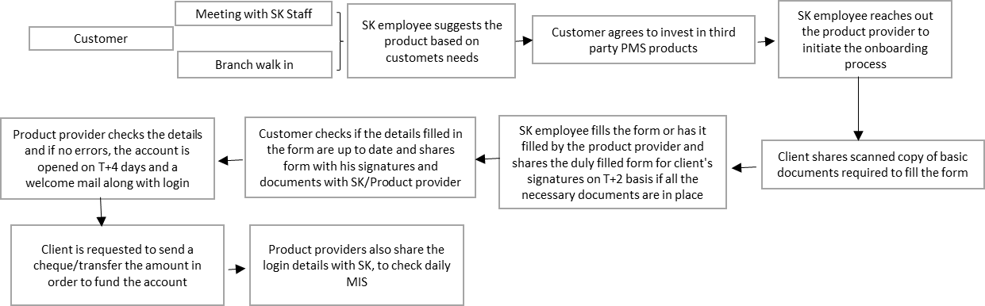

Business credit/Client Mapping
PMS Data/Deals:
Operation team will be responsible for maintaining the repository of all deals reports on PMS reported by the organisation.

Transaction Reporting & DPMS Mapping:
Details of the RM sourcing the business will be captured in the system as per below process:
RM will have to send an email to pms_sales@sharekhan.com along with soft copy of the first page of the client’s KYC document and following details:
- Employee Code
- Employee Name
- Segment
- Branch Code
- Branch Name
- Referrer Details (if applicable such as Employee Name and Code)

Customer Engagement Approach
At Sharekhan, the client engagement process is detailed below:
1. Client Meeting
(Face-to-Face/ Phone)
This stage involves engaging with the client usually in a meeting or interacting over a phone call
2. Need Analysis
During the interaction, the RM gathers information of the client’s investment /protection requirement
3. Execution
In order to fulfill the financial need, the client is offered the PMS product that suits his requirement

Documentation
All documents are retained in physical form with the product provider, and will be shared with Sharekhan on demand. All relationship managers engaging with clients on PMS products must follow the documentation process as prescribed by the PMS provider

Transaction Reporting (Business Credit)
Business credit will be given to relationship managers as per the client’s mapping in the DPMS systems. Equalization as announced for individual portfolios will be applicable under incentive plan for each segment and will be paid on the net collection amount
Please note that if a PMS deal is sourced by an employee of the sales and onboarding team then the sales credit for the same will be equally shared with the employee to whom the client is mapped to (from the segment) within 3 months of sourcing the deal. The credit sharing will be as follows:
For PMS business sourced within 3 months of account opening for accounts opened by Sales & On-boarding team:
Segment RM | 100% | If no Sales or On-boarding team member is involved
Segment RM | 50% | If Sales team member is involved
Sales Executive (if on-boarding team member is not involved) | 50% | If account is not mapped to On-boarding branch
Sales Executive (if on-boarding team member is involved) | 25% | If account is mapped to On-boarding branch
On-boarding Executive | 25% | If account is mapped to On-boarding branch

The above credit sharing process is still under discussion and will be updated once all vertical heads are in agreement. Meanwhile, request you to capture all the above details for information purpose.

Training and Accreditation
All customer-facing staff involved in sale of PMS products must be NISM Series V-A certified and must attend all product trainings organized from time to time.
Additionally, all staff involved in the sale of portfolio management services going forward will also have to obtain certification by passing the NISM NISM-Series-XXI-A: Portfolio Management Services (PMS) Distributors Certification Examination within two years from the date starting PMS distribution services.
All segment heads must put adequate controls in place to ensure that no staff is allowed to source PMS business without requisite certifications.

Sales Quality/Mis-selling
Mis-selling means selling a product by giving a wrong picture of a product, it may include, giving wrong information, giving unrealistic information, not giving full information about the product. It is direct indicator of the Sales quality. The Sales quality would be tracked by the mis-selling complaints from clients. In case mis selling is established the employee will face stringent action from the management included but not limited to clawback of incentive paid.

Post Sales- client servicing
Relationship manager sourcing the PMS deal is the first point of contact for the customer and will be responsible for helping the customer with the request. Branch staff shall be available for any servicing needs of PMS customers. Apart from visiting the branch, customers can approach any of the various touch points like Toll Free number or Customer service email. Branch staff will support servicing requirements of customers with the support of PMS team. Respective team will revert to the customer within the defined timelines.

Do’s and Don’ts (Code of Conduct)
- Ensure that NISM certification V-A is valid along with a valid Employee Unique Identification Number (EUIN)
- Ensure that NISM certification XXI-A is completed upon expiry of V-A certification or before December-2022 (whichever is earlier)
- Classify at the Customer Level whether “advisory” or “execution only” customer and necessary disclosure shall be made with the customer. This information is captured in the application form of the PMS provider that is required to be filled by the client.
- Be diligent in attesting / certifying investor documents and performing In-Person -Verification (IPV) of investor's for the KYC process in accordance with the guidelines prescribed by SEBI/ KYC Registration Agency (KRA) from time to time.
- Consider investor's interest as paramount and take necessary steps to ensure that the investor's interest is protected in all circumstances.
- Be fully conversant with the key provisions of the Disclosure Document and the contract being entered between the customer and the Portfolio Manager.
- Provide full and latest information of strategy solicited to investors in the form of performance reports including risk factors, portfolio strategy, deviations and highlight the assumptions if any.
- Disclose to the investors all material information including all the commissions received for the purpose of soliciting such Portfolio Management Strategy.
- Abstain from indicating or assuring returns in any type of strategy.
- Keep yourselves abreast with the developments relating to the Portfolio Management Industry as also changes in the disclosure documents, changes in controlling interest, loads, portfolio manager, and other material aspects and deal with the investors appropriately having regard to the up to date information.
- Maintain confidentiality of all investor details, deals and transactions.
- Always keep investor's interest and suitability to their financial needs as paramount and that extra commission or incentive should never form the basis for recommending a portfolio management strategy to the investor.
- Do not offer any rebate or commission back to investors and abstain from attracting investors through temptation of rebate/gifts etc.
- Do not undertake commission driven malpractices such as recommending inappropriate strategy solely because of higher commissions.
- Do not make negative statements about any other Portfolio Manager or strategy and ensure that comparisons, if any, are made with similar and comparable products along with complete facts.
- Observe high standards of ethics, integrity and fairness in all its dealings with all parties - investors, Portfolio Manager. Render at all times high standards of service, exercise due diligence, and ensure proper care.

